

**Western Australian Certificate of Education**

**ATAR course examination, 2020**

**Question/Answer Booklet**

12 PHYSICS

Name

**Evaluation - Gravitation**

|  |  |  |  |  |  |  |  |  |  |  |
| --- | --- | --- | --- | --- | --- | --- | --- | --- | --- | --- |
| Student Number: In figures |  |  |  |  |  |  |  |  |  |  |

**Mark: $\frac{}{\text{30}}$**  In words

#### Time allowed for this paper

Reading time before commencing work: five minutes

Working time for paper: fifty minutes

**Materials required/recommended for this paper**

To be provided by the supervisor

This Question/Answer Booklet

Formulae and Data Booklet

***To be provided by the candidate***

Standard items: pens, (blue/black preferred), pencils (including coloured), sharpener, correction fluid/tape, eraser, ruler, highlighters

Special items: non-programmable calculators satisfying the conditions set by the School Curriculum and Standards Authority for this course

**Important note to candidates**

No other items may be taken into the examination room. It is your responsibility to ensure that you do not have any unauthorised notes or other items of a non-personal nature in the examination room. If you have any unauthorised material with you, hand it to the supervisor before reading any further.

The table below describes the orbital paths of a number of natural and man-made satellites orbiting the Earth.

|  |  |  |  |  |  |
| --- | --- | --- | --- | --- | --- |
| **Name** | **Mass (kg)** | **Orbital Radius**  **(x 107 m)** | **Period**  **(x 104 s)** | **Acceleration (ms-2)** | **(Units: )** |
| Shuttle | 2.95 x 104 | 0.671 | 0.541 |  |  |
| Tiros | 1405 | 0.722 | 0.612 |  |  |
| Itos | 340 | 0.787 | 0.667 |  |  |
| Lageos | 411 | 1.23 | 1.35 |  |  |
| Nato | 310 | 4.22 | 8.64 |  |  |
| Moon | 7.38 x 1022 | 38.2 | 242 |  |  |

1. Using your knowledge of circular motion theory, show working to illustrate that the acceleration of each satellite is related to its orbital radius and its period by the expression:

$$\text{a =} \frac{\text{4}{\text{π}}^{\text{2}}\text{r}}{{\text{T}}^{\text{2}}}$$

(4 marks)

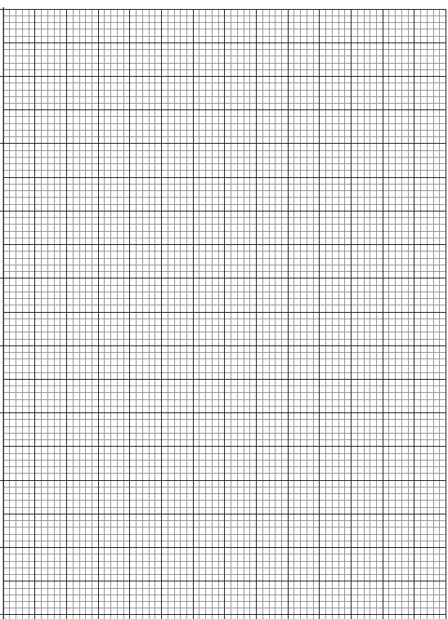

2. (a) Using the expression from Question 1, calculate and fill in the values for the **fifth column in the table above**. Ensure you display the values to the correct number of significant figures. (2 marks)

(b) Show workings for the calculation you performed to determine the acceleration of Lageos. (2 mark)

3. (a) Fill in the values of uncertainty associated with Lageos in the table below. (4 marks)

|  |  |  |  |
| --- | --- | --- | --- |
| **Quantity** |  | **Absolute Uncertainty** | **Percentage Uncertainty (%)** |
| Orbital Radius (x 107 m) | 1.23 |  |  |
| Period (s) | 1.35 x 104 |  |  |

(b) Using this information, calculate the percentage uncertainty (%) and absolute uncertainty for the acceleration of Lageos. (3 marks)

**Ans:** % Uncertainty acceleration: ____________________________

**Ans:** Absolute Uncertainty acceleration: _______________________

4. Complete the **sixth column of the table** on page 1 by calculating the values of **inverse of radius squared**. Clearly show the power of 10 and units by writing them at the top of that column.

(3 marks)

5. Plot a graph of gravitational field strength (**g**) against inverse of the radius squared (**1/r2**) on the grid on page 3. Include a line of best fit.

(A spare grid is on page 6.) (5 marks)

6. It is known that gravitational field strength due to the Earth can be calculated using the formula:

$$\text{g = }\frac{\text{G}{\text{M}}_{\text{E}}}{{\text{r}}^{\text{2}}}$$

Use your graph to determine the mass of the Earth. Show all working. (7 marks)

Spare grid

